CHAPTER II
PRODUCT SPECIFICATIONS

This chapter delved into the technical specifications essential for developing and implementing HydroSense. It aimed to comprehensively understand the system framework by detailing the hardware and software components, operating environment, and connectivity requirements. The chapter also addressed crucial design and implementation constraints, such as power needs and data accuracy, to ensure reliable and efficient system performance. Additionally, it outlined the assumptions and dependencies underpinning the project success, ensuring that each aspect of the system was robust and well-integrated.

2.1 Product Perspective and General Features
The device powered by Arduino, equipped with essential sensors and interfacing with a web application, offered a comprehensive solution for monitoring water quality. This integrated system provided users with real-time data on TDS, turbidity, water temperature, and pH, enabling informed decision-making regarding water safety. HydroSense multiple sensors ensured accurate data collection, while the web application intuitive interface presented actionable insights, water puri cation recommendations, and hydrology resources to empower users in managing water quality effectively. The combination of hardware and software components made HydroSense a reliable tool for personal and professional water quality monitoring. This holistic approach bridged the gap between technology and water safety. It fostered proactive water management for healthier communities. Figure 1 shows the four general features of HydroSense.
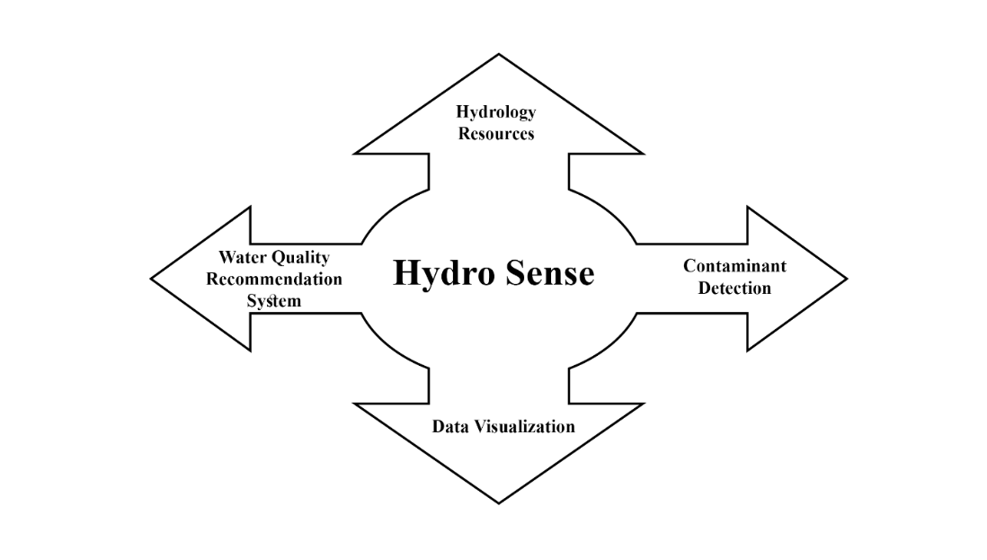
Figure 1. HydroSense General Features.

2.1.1 Contaminant Detection
It is a pivotal aspect of HydroSense, ensuring the accurate identification and assessment of harmful substances in the water. Using sensors like TDS, Turbidity, water temperature, and pH in the device offered a comprehensive view of water quality. These sensors provided real-time data on key parameters, enabling users to accurately monitor water condition changes. By utilizing these sensors, the device assesses water cleanliness and offers tailored recommendations for water purification methods. This feature empowered users to make informed decisions about water safety, ensuring access to clean and healthy water sources while promoting proactive measures for water quality management. It simplifies water monitoring while supporting sustainable water management practices. It also encourages informed actions for cleaner water sources.
2.1.2 Data Visualization
It offered a detailed insight into water quality parameters. Each sensor, including TDS, Turbidity, temperature, and pH, was accompanied by a real-time graph displaying data. This allowed users to track the historical trends of each parameter over time, facilitating a deeper understanding of water quality dynamics. Moreover, users view the real-time values of each sensor, providing immediate feedback on current water conditions. Additionally, the web application enabled users to download historical data in CSV format if they decided to save the sensor data, empowering them to conduct further analysis or share information with relevant stakeholders. This comprehensive functionality enhanced users' ability to monitor and manage water quality effectively, ensuring the continuous provision of clean and safe water resources.
2.1.3 Water Quality Recommendation
It provide users with guidance on how to purify their contaminated water based on sensor readings was a feature of the water quality recommendation system in the web application. It offered tailored suggestions for water purification methods by leveraging data collected from TDS, Turbidity, water temperature, and pH sensors. By analyzing these sensor readings, the recommendation system advised users on specific actions to clean their water effectively. This ensured that users addressed detected contaminants appropriately and maintained access to clean and safe water sources. This system enhanced user confidence in managing water safety. It promoted informed, timely actions for better water quality.
2.1.4 Hydrology Resources
This component feature of the web application provided a diverse collection of materials to enhance user understanding of water quality and safety. This feature included articles, guides, and videos addressing water quality monitoring, the health effects of contaminants like heavy metals and bacteria, and water purification and conservation strategies. Notable sources included the World Health Organization (WHO) guidelines for drinking water quality, the United States Geological Survey insights on turbidity and water temperature, and educational content from the Safe Drinking Water Foundation on TDS and pH. These resources ensured users had access to accurate, practical, and up-to-date information, empowering them to make informed water management and safety decisions.

2.2 Operating Environment
HydroSense operated with both hardware and software components to ensure seamless functionality. The hardware included the Arduino platform and various sensors, while the software encompassed the web application used for data visualization and recommendations. A stable internet connection was essential for real-time data transmission between the device and the web server. This integration allowed users to access and analyze water quality data from any internet-enabled device. This enables timely, informed decisions on water safety and management. By combining these elements, HydroSense provides a comprehensive and accessible solution for continuous water quality monitoring.
2.2.1 Hardware Requirements
As outlined in Table 2, the hardware requirements for HydroSense were crucial for its successful development and implementation. Identifying the necessary components and specifications ensured the system effectively performed its intended operations. The foundation provided by these components was essential for building a robust and functional system. The ESP32-WROOM-32D and Arduino Uno microcontrollers included sensors for measuring TDS, pH, Turbidity, and water temperature, a 0.96-inch OLED device screen, and a microSD storage module. Additionally, the system required an external 5V power source for operation. The project achieved accurate data collection and reliable performance by addressing these hardware needs.

Function Components | Development |  | Implementation
Arduino / Microcontroller | ESP32-WROOM-32D |  | ESP32-WROOM-32D
Arduino / Microcontroller | Arduino Uno |  | Arduino Uno
Sensors | SEN0244 | TDS | SEN0244 | TDS
Sensors | SEN0161 | pH | SEN0161 | pH
Sensors | TSW-20M | Turbidity | TSW-20M | Turbidity
Sensors | DS18B20 | Water Temperature | DS18B20 | Water Temperature
Device Screen | SSD1306 | 0.96-inch OLED | SSD1306 | 0.96-inch OLED
Storage | HW-125 | microSD Module | HW-125 | microSD Module
Power | External 5v Power Supply |  | External 5v Power Supply
Table 2. Hardware Requirements.
2.2.1.1 ESP32-WROOM-32D Microcontroller
Figure 2 highlights the ESP32-WROOM-32D microcontroller, primarily used to serve the web server in HydroSense. It facilitated real-time data transmission and communication between the sensors and the web application. This microcontroller built-in Wi-Fi capabilities enabled seamless connectivity, allowing users to access and monitor water quality data remotely. By leveraging the ESP32 powerful processing and connectivity features, the system ensured efficient and reliable performance.

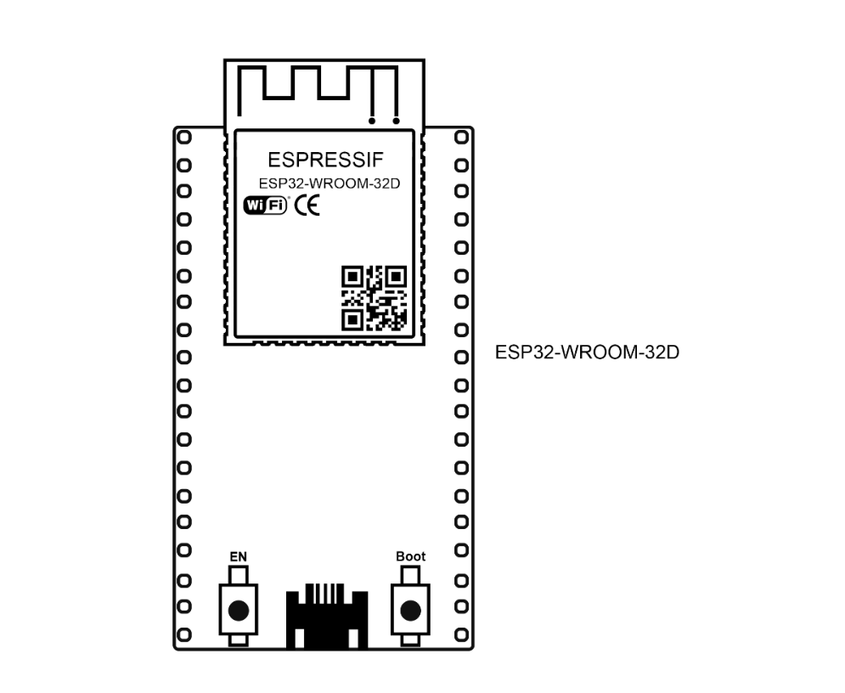
Figure 2. ESP32-WROOM-32D Microcontroller.

2.2.1.2 Arduino UNO
Figure 3 highlights the Arduino Uno microcontroller, primarily used for interfacing with the sensors in HydroSense. It facilitated real-time data acquisition from the Turbidity, pH, TDS, and temperature sensors. This microcontroller versatility and ease of use enabled seamless integration, allowing users to collect and process water-quality data efficiently. By leveraging the Arduino Uno robust features and extensive support community, the system ensured reliable and accurate performance in monitoring water safety.

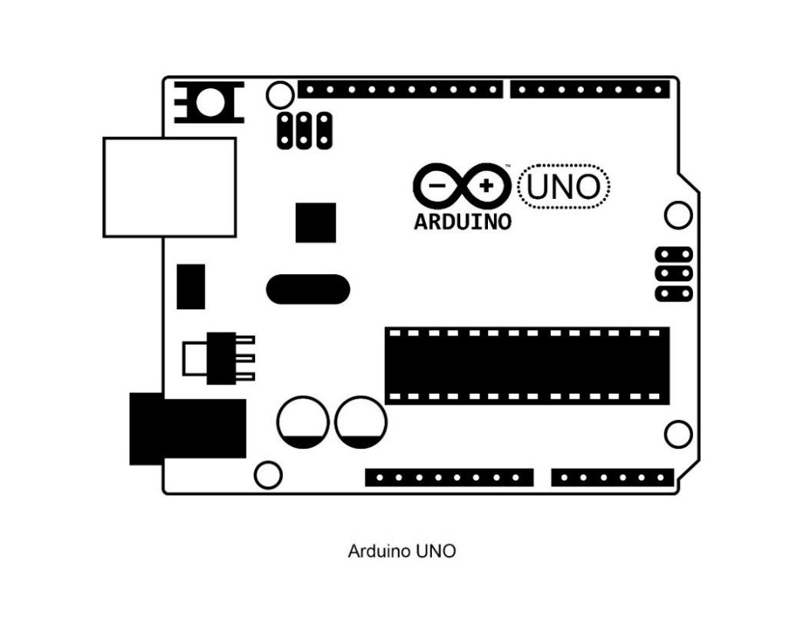Figure 3. Arduino UNO.

2.2.1.3 Sensor and Interface Boards
Figure 4 presents a detailed view of the individual sensors and their respective interface boards used in HydroSense. The sensors included the TDS sensor (SEN0244), temperature sensor (DS18B20), turbidity sensor (TSW-20M), and pH sensor (SEN0161), along with their interface boards for proper connectivity. Additionally, the diagram included the microSD card module (HW 125) to illustrate the storage solution for the system. The diagram helped users identify each component and understand their role in the overall system. This figure was essential for troubleshooting and ensuring correct sensor installation.

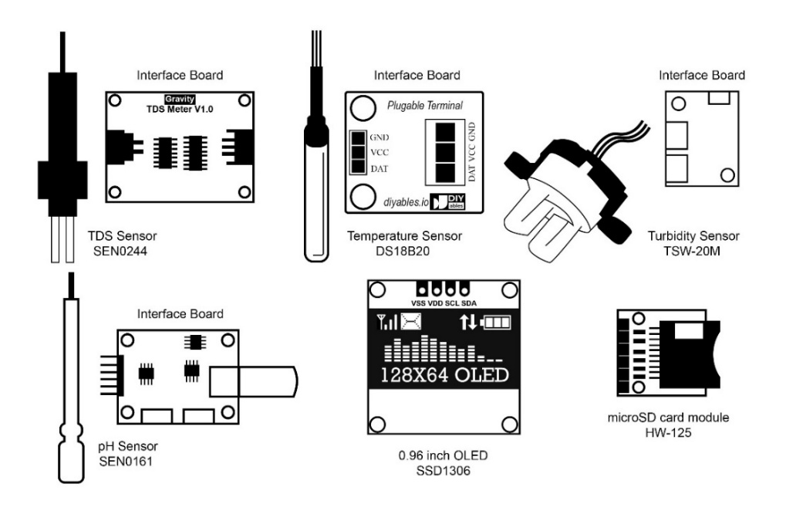
Figure 4. Sensor and Interface Boards.

2.2.1.4 Hardware Wiring Diagram
Figure 5 illustrates the connections between the ESP32-WROOM-32D microcontroller and the Arduino Uno, along with the various sensors used in HydroSense. The TDS, Turbidity, temperature, and pH sensors were interfaced with the Arduino Uno via specific interface boards. The Arduino Uno was connected to the ESP32-WROOM-32D microcontroller via a serial connection to transmit sensor data. Additionally, the diagram showed the microSD card module and the OLED display connected to the ESP32 for data storage and device interfacing.

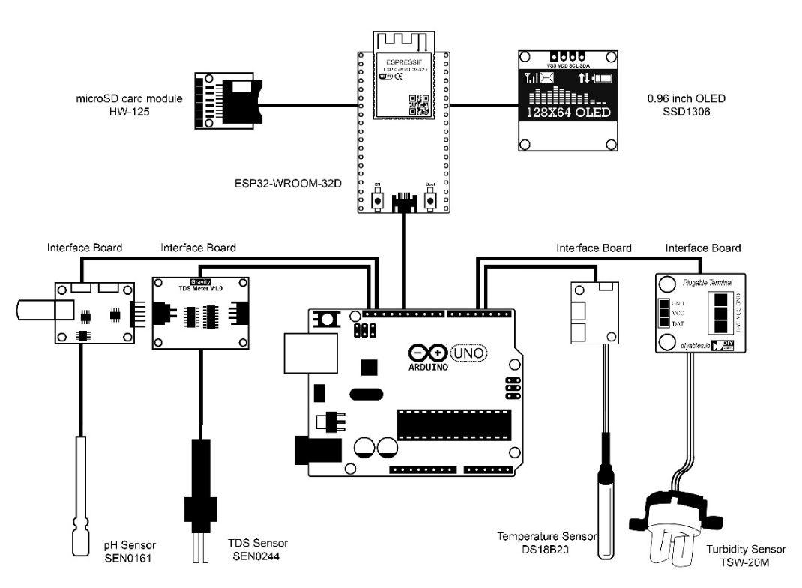
Figure 5. Hardware Wiring Diagram.

2.2.1.5 Sensor Placement in Water
Figure 6 demonstrates the HydroSense operation within a water environment, illustrating the placement of various sensors when submerged. The pH sensor measured the water acidity or alkalinity, the TDS sensor monitored dissolved substances, the temperature sensor tracked water temperature, and the turbidity sensor assessed water clarity. Each sensor was connected to the Arduino Uno via its respective interface board, facilitating proper data transmission. The Arduino Uno sent the collected sensor data to the ESP32-WROOM-32D microcontroller via a serial connection. The microcontroller collected and processed the data, displaying it on the OLED screen and storing it on the microSD card for real-time monitoring and logging.

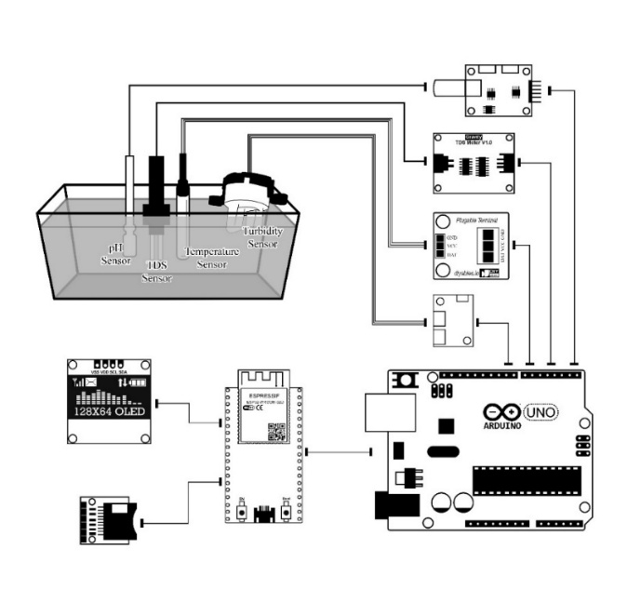
Figure 6. Sensor Placement in Water Diagram.
2.2.2 Software Requirements
Visual Studio Code and Arduino IDE were employed as the primary code editors. The operating system used was Windows 11, ensuring compatibility with the latest software applications during the project development. The programming languages C++ and JavaScript were integrated for robust backend functionality, while HTML and CSS were utilized for front-end development to create a dynamic and user-friendly interface. Communication among the developers was streamlined through platforms like Facebook Messenger and Microsoft Teams, facilitating virtual meetings. The web application underwent rigorous testing on multiple browsers, including Google Chrome, Firefox, and Brave, to ensure broad compatibility. The software specifications for the project were outlined in Table 3 and accessible to the project team.

Component | Software Tool
Code Editor | Visual Studio Code, Arduino IDE
Operating System | Windows 11
Programming Languages | C++, JavaScript
Front-end Development | HTML, CSS
Communication Platforms | Facebook Messenger, Microsoft Teams
Browser | Google Chrome, Firefox, Brave
Table 3. Software Requirements.

2.2.3 Connectivity Requirements
HydroSense requires a stable internet connection and compatibility with Wi-Fi for seamless communication. This ensured the device connected to the web application to transmit real-time water quality data and receive updates or recommendations. Just as different browsers were essential for deploying and testing web applications, a reliable internet connection was crucial for integrating the device and enabling easy access to online services like web hosting. Table 4 shows the prerequisites fundamental for the development and successful implementation of the project.

Component | Specification
Mode of Connection | Wi-Fi
Wi-Fi Range | ~15 – 20 meters in line of sight
Internet Connection | 10 Mbps
Table 4. Connectivity Requirements.

2.3 Design and Implementation Constraints
The developers acknowledged critical factors that shaped the system development and functionality by outlining the design and implementation constraints. These constraints encompass power requirements, crucial for sustaining device operation, and data accuracy requirements, essential for reliable water quality monitoring. To address these constraints ensured the project aligned with its objectives and fostered user confidence in the system performance. The project also had to consider environmental factors that affect sensor accuracy and durability. Additionally, the reliance on a stable internet connection for real-time data transmission posed a constraint, necessitating dependable network availability. Understanding and mitigating these constraints were vital for the successful implementation and long-term effectiveness of HydroSense.
2.3.1 Power Requirement
The device primarily operated using a 5V power supply via a USB connection, ensuring compatibility and ease of access to power. Additionally, the device utilized an off-the-shelf battery bank rated at 5000mAh for scenarios where portability or uninterrupted operation was essential. This battery bank was estimated to provide enough power for about seven days of continuous operation, ensuring prolonged functionality without frequent recharging or replacing power sources. The charging time of the battery bank was about three to four hours. These specifications underscored the device adaptability to various environments and its capability to maintain reliable operation while addressing power constraints effectively.
2.3.2 Sensor Data Accuracy
Table 5 provides a comparison based on the accuracy of data gathered by different sensors used in HydroSense and the formula for assessing water quality based on sensor data. Ensuring data accuracy posed a significant constraint, especially considering the variability in environmental conditions and potential sources of interference. Achieving reliable and accurate sensor readings was crucial for building user trust and confidence in the device functionality. This constraint necessitated thorough testing and calibration of sensors during both the manufacturing and deployment phases to guarantee consistent performance. Regular maintenance and recalibration were also required for sensor drift and wear. Additionally, the system had to account for potential inaccuracies caused by temperature fluctuations, electromagnetic interference, and physical obstructions.

+Sensor Type | Range | Description | Accuracy
TDS Sensor | Data < 300ppm | Excellent | ±2% ppm
TDS Sensor | Data between 300ppm – 600ppm | Good | ±2% ppm
TDS Sensor | Data between 600ppm – 900ppm | Fair | ±2% ppm
TDS Sensor | Data between 900ppm – 1,200ppm | Poor | ±2% ppm
TDS Sensor | Data > 1,200ppm | Unacceptable | ±2% ppm
Turbidity Sensor | Data ≤ 1 NTU | Ideal Turbidity | ±5% NTU
Turbidity Sensor | Data ≤ 5 NTU | Drinkable Water | ±5% NTU
Turbidity Sensor | Data > 5 NTU | Dirty Water | ±5% NTU
pH Sensor | Data < 6.5pH | Not Acceptable | ±0.1 pH
pH Sensor | Data between 6.5pH – 8.5pH | Acceptable | ±0.1 pH
pH Sensor | Data > 8.5pH | Not Acceptable | ±0.1 pH
Water Temperature Sensor |  |  | ±0.5°C
Table 5. Ranges and its Description.

2.3.3 Water Quality Parameter Ranges
This section elaborated on the specific ranges and descriptions of water quality parameters measured by HydroSense. Understanding these ranges was crucial for accurately assessing water quality and making informed decisions regarding water treatment. Each parameter measured by the system had a specific range that indicated different water quality levels. These ranges provided valuable insights into the overall health of the water source, allowing for appropriate corrective actions when necessary.
2.3.3.1 TDS Sensor Ranges
The TDS sensor measured the concentration of dissolved solids in water. High levels of TDS indicate the presence of various contaminants, including salts, minerals, and metals. The following table provides the ranges and corresponding descriptions for TDS levels. Table 6 shows the descriptions that helped users understand the potential impact of TDS on water quality.

TDS Range | Description
Data < 300ppm | Lowest amount of dissolved solids
Data between 300ppm – 600ppm | Low to moderate amount of dissolved solids
Data between 600ppm – 900ppm | Moderate amount of dissolved solids
Data between 900ppm – 1200ppm | High amount of dissolved solids
Data > 1200ppm | Very high amount of dissolved solids
Table 6. TDS Sensor Ranges and Descriptions.

2.3.3.2 Turbidity Sensor Ranges
The turbidity sensor measured the cloudiness or haziness of water caused by suspended particles. High turbidity levels indicate the presence of pollutants, pathogens, or organic matter, which affect water safety. Understanding these ranges helped users evaluate the aesthetic and health-related quality of the water. Table 7 shows the ranges and their descriptions.
Turbidity Range | Description
Data ≤ 1 NTU | Low amount of suspended particles
Data ≤ 5 NTU | Moderate amount of suspended particles
Data > 5 NTU | High amount of suspended particles
Table 7. Turbidity Sensor Ranges and Descriptions.

2.3.3.3 pH Sensor Ranges
The pH sensor measured the acidity or alkalinity of the water. It was crucial for assessing water corrosiveness and chemical balance. Proper pH levels ensured water safety and protected plumbing. Table 8 outlines the pH ranges and their descriptions.

pH Range | Description
Data between 0pH – 2.3pH | Strongly acidic water
Data between 2.4pH – 4.6pH | Moderately acidic water
Data between 4.7pH – 6.4pH | Weakly acidic water
Data between 6.5pH – 8.5pH | Neutral water
Data between 8.6pH – 10pH | Weakly alkaline water
Data between 10.1pH – 12pH | Moderately alkaline water
Data between 12.1pH – 14pH | Strongly alkaline water
Table 8. pH Sensor Ranges and Descriptions.
2.3.4 Hardware to Software Interfacing
Efficient interfacing between hardware components and the software application was pivotal for displaying Arduino sensor readings. The system relied on a stable internet connection with a minimum speed of 10 Mbps to transmit sensor data from the Arduino-powered device to the web server for real-time display. Utilizing a dedicated web server facilitated seamless communication between the device and the web application, ensuring that sensor readings were accurately displayed to users. This integration optimized the system functionality, allowing users to access timely sensor data and simplifying the monitoring process while maintaining real-time data visualization.
2.3.5 Graphical Data Visualization
This played a crucial role in interpreting the results of the data collected by the sensors. Graphical representation of water quality parameters, such as TDS, Turbidity, pH, and temperature, allowed users to easily comprehend trends and variations. By incorporating interactive graphs and charts into the web application interface, users were able to visualize real-time data clearly and intuitively, facilitating informed decision-making regarding water management practices. These visualizations provided valuable insights into water quality dynamics, enabling users to identify patterns and anomalies effectively and contributing to maintaining clean and safe water sources. Moreover, the ability to customize visualizations according to user preferences enhanced the overall user experience and usability of the system.
2.3.6 Water Treatment Recommendation
The system faced challenges in providing accurate water treatment recommendations due to the varying levels and types of contaminants detected by the sensors. Sensors detected diverse contaminants, making it necessary to consider the type, concentration, and water quality standards for suitable treatment recommendations. The system had to analyze real-time data from TDS, Turbidity, water temperature, and pH sensors to generate specific and effective treatment methods. Environmental factors, such as temperature and pH, influenced the effectiveness of certain treatments, adding complexity to the recommendation process. Additionally, the system needed to provide easy-to-understand, actionable steps for users, which required simplifying complex data into user-friendly guidance. Despite these challenges, the system offered easy, homemade treatments that required no specialized equipment.
Furthermore, the system had to account for regional water quality variations and regulatory differences affecting treatment efficacy and safety. Integrating machine learning algorithms to predict treatment outcomes based on historical data enhances recommendation accuracy. User feedback loops were essential to continuously re-evaluate and improve the treatment suggestions provided by the system. The system must regularly update its database with the latest water treatment research and emerging contaminants to ensure reliability. Table 9 illustrates how the system analyzes sensor data, environmental factors, and user feedback to generate accurate water treatment recommendations.
TDS Range | Turbidity Range | pH range | Recommendation
TDS < 300ppm | Turbidity ≤ 1 NTU | 6.5pH – 8.5pH | Water is safe to drink.
TDS < 300ppm | Turbidity ≤ 1 NTU | 4.7pH – 6.4pH | Gradually add small amounts of baking soda to increase pH to neutral range. (0.1g)
TDS < 300ppm | Turbidity ≤ 1 NTU | 8.6pH – 10pH | Gradually add a few drops of lemon juice or vinegar to decrease pH to neutral range. (1 drop)
TDS < 300ppm | Turbidity ≤ 5 NTU | 6.5pH – 8.5pH | Let water settle (Sedimentation) then use a cloth filter (Filtration).
TDS < 300ppm | Turbidity ≤ 5 NTU | 4.7pH – 6.4pH | Let water settle (Sedimentation) then use a cloth filter (Filtration). Gradually add small amounts of baking soda to increase pH to neutral range. (0.1g)
TDS < 300ppm | Turbidity ≤ 5 NTU | 8.6pH – 10pH | Let water settle (Sedimentation) then use a cloth filter (Filtration). Gradually add a few drops of lemon juice or vinegar to decrease pH to neutral range. (1 drop)
301ppm - 900ppm | Turbidity ≤ 1 NTU | 6.5pH – 8.5pH | Boil the water and collect its condensation (Distillation).
301ppm - 900ppm | Turbidity ≤ 1 NTU | 4.7pH – 6.4pH | Boil the water and collect its condensation (Distillation). Gradually add small amounts of baking soda to increase pH to neutral range. (0.1g)
301ppm - 900ppm | Turbidity ≤ 1 NTU | 8.6pH – 10pH | Boil the water and collect its condensation (Distillation). Gradually add a few drops of lemon juice or vinegar to decrease pH to neutral range. (1 drop)
301ppm - 900ppm | Turbidity ≤ 5 NTU | 6.5pH – 8.5pH | Boil the water and collect its condensation (Distillation). Let water settle (Sedimentation) then use a cloth filter (Filtration).
301ppm - 900ppm | Turbidity ≤ 5 NTU | 4.7pH – 6.4pH | Boil the water and collect its condensation (Distillation). Let water settle (Sedimentation) then use a cloth filter (Filtration). Gradually add small amounts of baking soda to increase pH to neutral range. (0.1g)
301ppm - 900ppm | Turbidity ≤ 5 NTU | 8.6pH – 10pH | Boil the water and collect its condensation (Distillation). Let water settle (Sedimentation) then use a cloth filter (Filtration). Gradually add a few drops of lemon juice or vinegar to decrease pH to neutral range. (1 drop)
TDS > 900 ppm | Any | Any | No homemade treatment can safely treat this water.
Any | Turbidity > 5 NTU | Any | No homemade treatment can safely treat this water.
Any | Any | 0pH – 4.6pH | No homemade treatment can safely treat this water.
Any | Any | 10.1pH – 14pH | No homemade treatment can safely treat this water.
Table 9. Formula for Recommending Water Treatments.
2.3.7 Hydrology Resources
The hydrology resources component of HydroSense was designed to provide users with access to a comprehensive repository of educational materials on water quality and management practices. Drawing from reputable sources such as the World Health Organization (WHO), Centers for Disease Control and Prevention (CDC), National Library of Medicine, and other scholarly and governmental organizations, the application included articles, guides, videos, and studies. These resources covered topics like pH, turbidity, total dissolved solids (TDS), water temperature, and various water treatment methods such as boiling, filtration, and aeration. By presenting accurate and up-to-date information, the component aimed to enhance user awareness and understanding of water safety, the health effects of contaminants, and best practices for water conservation and purification. The references and detailed breakdown of sources are listed in Appendix Q through AB, categorizing the information by topic and type.
2.3.8 Sensor Durability Against High Acidity and Alkalinity
HydroSense faced constraints related to the durability and accuracy of sensors when exposed to highly acidic (low pH) or highly alkaline (high pH) environments. Extreme pH levels corrode or damage the sensors, leading to inaccurate readings or sensor failure. As a result, the system cannot reliably monitor water quality in conditions where the pH falls outside the optimal range for sensor operation. This limitation must be acknowledged, and users potentially be informed of the potential impact on sensor performance when water pH levels are too high or too low. To mitigate this issue, regular calibration and maintenance of the sensors are essential to extend their operational lifespan and improve accuracy. Ensuring sensor protection and accuracy was crucial for maintaining the reliability of the water quality data provided by the system.
2.3.9 Health Risk Evaluation System
The Health Risk Evaluation System provides a framework for analyzing water safety based on key parameters: TDS, turbidity, and pH. This system uses sensor data to interpret these parameters and generate detailed health risk assessments and treatment recommendations tailored to specific water quality conditions. By offering in-depth explanations of potential health risks associated with various water quality scenarios, it empowers users to make informed decisions about water consumption and treatment. The system enhances user understanding by correlating specific water quality ranges with associated health risks, providing actionable insights for mitigation. It integrates real-time data processing with a robust algorithm to deliver timely alerts about unsafe water conditions. This comprehensive approach not only alerts users to potential dangers but also educates them about the importance of water quality in maintaining health. This system ensures users take proactive steps to safeguard their health. Additionally, it provides users with practical guidance on improving water quality to mitigate identified risks. Table 10 presents a comprehensive overview of potential health risks associated with various combinations of water quality parameters, offering a valuable reference for risk assessment.
TDS Range | Turbidity Range | pH Range | Potential Health Risk
TDS < 300ppm | Turbidity ≤ 1 NTU | 6.5pH – 8.5pH | Generally safe, minimal health risks
TDS < 300ppm | Turbidity ≤ 1 NTU | 4.7pH – 6.4pH | Mild gastrointestinal irritation. Potential for dental erosion
TDS < 300ppm | Turbidity ≤ 1 NTU | 8.6pH – 10pH | Mild gastrointestinal irritation
TDS < 300ppm | Turbidity ≤ 5 NTU | 6.5pH – 8.5pH | Increased risk of waterborne diseases (bacterial, viral, parasitic). Gastrointestinal issues (diarrhea, vomiting)
TDS < 300ppm | Turbidity ≤ 5 NTU | 4.7pH – 6.4pH | Increased risk of waterborne diseases. Gastrointestinal issues. Potential for dental erosion.
TDS < 300ppm | Turbidity ≤ 5 NTU | 8.6pH – 10pH | Increased risk of waterborne diseases. Gastrointestinal issues.
301ppm - 900ppm | Turbidity ≤ 1 NTU | 6.5pH – 8.5pH | Potential for mild gastrointestinal issues. Possible mineral imbalances.
301ppm - 900ppm | Turbidity ≤ 1 NTU | 4.7pH – 6.4pH | Gastrointestinal issues. Dental erosion. Possible mineral imbalances.
301ppm - 900ppm | Turbidity ≤ 1 NTU | 8.6pH – 10pH | Gastrointestinal issues. Possible mineral imbalances.
301ppm - 900ppm | Turbidity ≤ 5 NTU | 6.5pH – 8.5pH | Increased risk of waterborne diseases. Gastrointestinal issues. Possible mineral imbalances.
301ppm - 900ppm | Turbidity ≤ 5 NTU | 4.7pH – 6.4pH | Increased risk of waterborne diseases. Gastrointestinal issues. Dental erosion. Possible mineral imbalances.
301ppm - 900ppm | Turbidity ≤ 5 NTU | 8.6pH – 10pH | Increased risk of waterborne diseases. Gastrointestinal issues. Possible mineral imbalances.
TDS > 900 ppm | Any | Any | Severe gastrointestinal distress. Kidney problems. Cardiovascular issues. Mineral toxicity or deficiency.
Any | Turbidity > 5 NTU | Any | High risk of waterborne diseases (cholera, typhoid, hepatitis A). Parasitic infections (giardiasis, cryptosporidiosis). Severe gastrointestinal issues.
Any | Any | 0pH – 4.6pH | Severe chemical burns to mouth, throat, and digestive tract. Dental erosion. Metabolic acidosis.
Any | Any | 10.1pH – 14pH | Severe chemical burns to mouth, throat, and digestive tract. Metabolic alkalosis.
Table 10. Health Risk Evaluation System.
2.3.10 Use of Web Server
The project used a dedicated web server to integrate hardware and software components seamlessly. The reliability of the web server was essential for the continuous operation of the system. Additionally, users had to have compatible devices and browsers to interact with the web-based application. Table 11 lists the compatible browsers and their versions for desktop and Android platforms.

Browser | Desktop Version | Android Version
Google Chrome | Minimum version 125.0 | Minimum version 125.0
Firefox | Minimum version 126.0 | Minimum version 126.0
Brave | Minimum version 1.66.115 | Minimum version 1.66.113
Table 11. Compatible Browsers and their Versions.

2.4 Assumptions and Dependencies
The project assumed that the chosen sensors and Arduino platform accurately measured water quality parameters within acceptable tolerances. Additionally, it depended on the availability of compatible development tools and technologies for hardware and software aspects. Furthermore, dependencies included access to reliable data sources and resources for validation, ensuring the system functionality and accuracy.
2.4.1 Assumptions
This section outlined the key assumptions fundamental to the development and functionality of Hydrosense. These assumptions encompassed various aspects, ranging from sensor accuracy to the functionality of formulas used for assessing water quality parameters and recommending treatments. Each assumption played a critical role in ensuring the reliability, effectiveness, and seamless operation of the system. By acknowledging and addressing these assumptions, the project aimed to mitigate potential risks and challenges, thereby enhancing the overall success and impact of the water quality monitoring endeavor.
2.4.1.1 Sensor Accuracy
The project assumed that the selected sensors, including TDS, Turbidity, pH, and water temperature sensors, accurately measured water quality parameters within acceptable tolerances. This was crucial for the reliability and effectiveness of the data collected. The accuracy of these sensors underpinned the project ability to provide actionable insights. Ensuring precise measurements was fundamental to achieving the project goals.
2.4.1.2 Availability of Development Tools
It was assumed that there be access to compatible development tools and technologies for both hardware and software aspects of the project. This included access to Arduino IDE for programming the Arduino platform and Visual Studio Code for developing and debugging the web application. Ensuring the availability of these tools streamlined the development process and facilitated efficient implementation of system functionalities. Comprehensive documentation and community support offered valuable guidance, reducing troubleshooting time and improving project efficiency.
2.4.1.3 Access to Reliable Data Sources
The project relied on access to reliable data sources and resources for validation purposes. This included datasets for calibrating sensors, historical water quality data for comparison and analysis, and authoritative sources for validating recommendations and hydrology resources. The availability of these resources was crucial for verifying the accuracy and effectiveness of the system in monitoring water quality and providing actionable insights to users.
2.4.1.4 Functionality of Formulas
The project also assumed that the formulas above for assessing water quality parameters and recommending water treatments were accurate and functional. These formulas provided users with actionable insights and recommendations based on sensor readings. Regular validation and testing were conducted to ensure the accuracy and reliability of these formulas in real-world scenarios.
2.4.1.5 Hardware-Software Compatibility
Another assumption was the compatibility of chosen hardware and software components, which minimized integration challenges during development. This entailed ensuring that the sensors, Arduino platform, and web application were seamlessly integrated and communicated effectively. Compatibility testing was conducted to identify and resolve any compatibility issues, ensuring the smooth operation of the entire system.
2.4.2 Dependencies
The success of the water quality monitoring project hinged on a series of dependencies vital for its seamless operation and effectiveness. These dependencies encompassed critical elements ranging from integrating sensor technologies to visualizing data on the web platform. Each dependency played a crucial role in ensuring the accuracy, reliability, and accessibility of water quality information to users. By understanding and addressing these dependencies, the project aimed to create a robust infrastructure capable of effectively delivering actionable insights and promoting awareness about water safety practices.
2.4.2.1 Seamless Sensor Integration
The project success relied on the seamless integration between various sensors utilized for water quality monitoring. Sensors such as DS18B20 for water temperature, TSW-20M for Turbidity, SEN0244 for TDS measurement, and SEN0161 for pH assessment played pivotal roles in gathering accurate data across multiple parameters. This integration ensured that the system provided reliable and comprehensive insights into the quality of water sources being monitored. This integration boosts the system effectiveness. Users trust the data collected and make informed decisions regarding water safety and management by ensuring that each sensor communicates effectively with the system. Additionally, the system real-time alerts empower users to respond swiftly to any water quality issues and this ensures proactive management of water resources.
2.4.2.2 Interoperability with Web Server
The project success depended on the interoperability of the web server for interfacing with the Arduino device. The web server facilitated seamless communication between the device and the web application, enabling real-time data transmission and visualization. This integration streamlined data management processes and ensured that users had access to up-to-date information on water quality parameters. With the web server, users monitor changes in water conditions promptly and take appropriate actions to address any issues detected.
2.4.2.3 Web Server for Data Visualization
The project dependency on the web server extended to data visualization, enabling the generation of graphical and chart-based representations of water quality parameters. This functionality facilitated intuitive analysis and interpretation of data, empowering users to identify trends and anomalies effectively. With visualizations generated through the web server, users gain deeper insights into water quality dynamics and make informed decisions regarding water management practices. By leveraging data visualization capabilities, the project enhanced the user experience and promoted proactive measures for ensuring clean and safe water sources.
2.4.2.4 Access to External Data Sources
The project relied on external data sources for hydrology resources. Access to comprehensive information on water safety practices and management was essential for empowering users to make informed decisions regarding their water sources. The project aimed to enhance awareness and understanding of water quality issues by providing users with access to reputable and authoritative hydrology resources. Users leverage this knowledge to implement effective water purification methods and contribute to maintaining clean and safe water sources.
2.4.2.5 Dependency on Hardware for Data Collection
The software component of HydroSense depended on the hardware for accurate data collection. The sensors integrated with the Arduino platform measured key water quality parameters such as TDS, Turbidity, pH, and temperature. Without reliable data from these sensors, the software does not process, visualize, or provide meaningful insights regarding water quality. This dependency highlighted the critical role of the hardware in ensuring the overall functionality of the system. Any hardware failure or malfunction directly impacts the software ability to deliver accurate and timely information to the users. Therefore, maintaining the hardware performance and ensuring proper integration with the software was essential for successfully operating the entire system.

This chapter outlined the technical specifications for the HydroSense water quality monitoring system, detailing its essential components and operational requirements. The system, powered by an Arduino microcontroller and equipped with TDS, Turbidity, temperature, and pH sensors, interfaced with a web application to provide real-time water quality data. Key features included contaminant detection, data visualization, tailored recommendations, and hydrology resources. The chapter also covered hardware and software needs, connectivity, design constraints, and dependencies. This comprehensive examination ensured the system effective development, accurate monitoring, and user-friendly interface for maintaining water safety. Moreover, it highlighted the system adaptability to varying environmental conditions and its ability to provide actionable insights for improving water quality. By combining advanced sensor technology with an intuitive web interface, HydroSense empowers users to make informed decisions, ensuring clean and safe water access. This thorough technical foundation paves the way for future enhancements and scalability of the system.

